DANE COUNTY
DEPARTMENT OF ADMINISTRATION
PURCHASING DIVISION

REQUEST FOR BID (RFB)
Revised 02/2020 (S)(LVP)(LCP)

BID NUMBER: | 120072
BID TITLE: | Renewable Gas Plant Media
BID DEADLINE: | December 1, 2020  2:00 p.m. (CST)
BIDS MUST BE UPLOADED TO: | Purchasing Bid Dropbox  www.danepurchasing.com

*Late, faxed, mailed, hand-delivered or unsigned bids will be rejected*

DIRECT  ALL INQUIRES TO: | Pete Patten
 | Purchasing Officer
 | 608-267-3523
 | patten.peter@countyofdane.com
 | www.danepurchasing.com

BID SUBMISSION CHECKLIST
Update Vendor  Registration  Read Entire Bid  Document | Completed Bid Packet (In PDF Format)  Section 2 – Vendor Information  Section 3 – Bid Specifications  Section 4 – Price Proposal  Section 5 – Standard Terms & Conditions | Upload Bid  Response to  Purchasing Bid  Dropbox

DATE ISSUED | October 30, 2020

- Introduction
Dane County invites and will accept bids for item(s) outlined within this bid. The County as represented by Purchasing Division, intends to use the results of this process to purchase goods or services here within.

- Clarification/Questions:
Any questions concerning this bid must be submitted in writing by email at least five working days prior to the bid deadline. Requests submitted after that time will not be considered. All inquiries must be directed to the Purchasing Agent indicated on the cover page.

- Addendums:
In the event that it becomes necessary to provide additional clarifying data or information, or to revise any part of this bid, addenda and/or supplements will be posted on the Purchasing Division web site at www.danepurchasing.com. Bidders are responsible to regularly monitor the web site for any such postings. It is recommended to check the website for addenda prior to submitting a proposal. Bidders must acknowledge the receipt/review of any addenda on the Vendor Information page.

The Purchasing Division has the sole authority for modifications to specifications and/or this bid document.

- Vendor Registration Program:
All bidders are strongly encouraged to be a registered vendor with Dane County. Registering allows a vendor the opportunity to receive notifications for bids issued by the County and provides the County with up-to-date company contact information.

Provide your Dane County Vendor # in the Vendor Information section of the bid submission packet.

For Non-Registered Vendors:
Complete vendor registration by visiting www.danepurchasing.com. On the top menu bar, click Vendor Registration and then click Create Vendor Account. You will receive an email confirmation once your account is created and again when your vendor registration is complete. Retain your user name/email address and password for ease of re-registration in future years. Within 2-4 days of completing the registration, a vendor number will be assigned and emailed to you.

For Registered Vendors:
Check to make sure your vendor information including commodity codes is up-to-date by signing into your account at www.danepurchasing.com. On the top menu bar, click Vendor Registration and then click Vendor Log In.

- Local Purchasing Preference:
Under Dane County Ordinance 25.08(11)(c-e), a Locally Based and Owned Vendor, Locally Operated Vendor, or Non-Locally Operated Vendor may be invited to match the low bid if the low bid is offered by a vendor that is not identified as a Locally Based and Owned Vendor, Locally Operated Vendor, or Non-Locally Operated Vendor according to Dane County Ordinance requirements.

Locally Based and Owned Vendor Criteria
- Your business or corporate headquarters is physically located in Dane County and;
- Your business owners or shareholders totaling more than 50% of ownership live in Dane County and;
- Your business is registered and authorized to do business in the State of Wisconsin.

Locally Operated Vendor Criteria
- Your business is registered and authorized to do business in the State of Wisconsin and;
- Your business has an established place of business within Dane County.
    - A post office box address does not qualify a vendor as a Locally Operated Vendor.

Non-Locally Operated Vendor Criteria
- Your business is registered and authorized to do business in the State of Wisconsin and;
- Your business has an established place of business in one of the following Wisconsin Counties: Columbia, Dodge, Green, Iowa, Jefferson, Rock, or Sauk.
  - A post office box address does not qualify a vendor as a Non-Locally Operated Vendor.

Local Purchasing Preference Order of Events:
Locally Based and Owned Vendors:
- When bids are reviewed, the County will determine if a Locally Based and Owned Vendor responding to the bid is the low bidder. If a Locally Based and Owned Vendor is the low bidder, they will be awarded the bid.
- If a Locally Based and Owned Vendor is not the low bidder but is within 15% of the low bid, the County will contact the Locally Based and Owned Vendor and provide that vendor the option of matching the low bid price.
- If no Locally Based and Owned Vendors are among the responding bidders, or the Locally Based and Owned Vendor declines to match the low bid, then the County will determine if a Locally Operated Vendor has responded to the bid.

Locally Operated Vendors:
- If a Locally Operated Vendor is within 10% of the low bid, the County will contact the Locally Operated Vendor and provide that vendor the option of matching the low bid price.
- If no Locally Operated Vendors are among the responding bidders, or the Locally Operated Vendor declines to match the low bid, then the County will determine if a Non-Locally Operated Vendor has responded to the bid.

Non-Locally Operated Vendors:
- If a Non-Locally Operated Vendor is within 5% of the low bid, the County will contact the Non-Locally Operated Vendor and provide that vendor the option of matching the low bid price.
- If no Non-Locally Operated Vendors are among the responding bidders, or the Non-Locally Operated Vendor declines to match the low bid, then the County will award the bid to the low bidder without regard to the location of the vendor.

- Local Content Preference:
Under Dane County Ordinance 25.08(4)(f-j), bidders offering goods made in Dane County, its surrounding counties, or the State of Wisconsin receive a price preference on sealed bid solicitations. Bids are first evaluated to determine if any bidders are offering products that qualify as Dane County-Made Goods, Regionally-Made Goods, or Wisconsin-Made Goods.

Dane County Made Criteria
- An article that is manufactured, mined, produced or grown in Dane County and;
- Over 50% of the total cost of its components are made in Dane County.
  - “Component”, as referenced above, means an article, materials, or supply incorporated directly into a finished product.

Regionally Made Criteria
- An article that is manufactured, mined, produced or grown in one of the following counties: Dane, Columbia, Dodge, Green, Iowa, Jefferson, Rock, or Sauk and;
- Over 50% of the total cost of its components are made in one of the following counties: Dane, Columbia, Dodge, Green, Iowa, Jefferson, Rock, or Sauk.
  - “Component”, as referenced above, means an article, materials, or supply incorporated directly into a finished product.

Wisconsin Made Criteria
- An article that is manufactured, mined, produced or grown in the State of Wisconsin and;
- Over 50% of the total cost of its components are made in the State of Wisconsin.
  - “Component”, as referenced above, means an article, materials, or supply incorporated directly into a finished product.

A bidder offering Dane County-Made Goods will be considered the successful bidder if their price is up to 15% higher than the low bid for goods that are not Dane County-Made Goods. If no vendors meet this criteria, then the County will determine if any bidder is offering Regionally-Made Goods. If so, then such a bidder will be considered successful if their price is up to 12.5% higher than the low bid for goods that are not Regionally-Made Goods. If no vendors meet this criteria, then the County will determine if any bidder is offering Wisconsin-Made Goods. If so, that bidder will be considered successful if their price is up to 10% higher than the low bid for goods that are not Wisconsin-Made Goods. If no vendors are offering Dane County-Made, Regionally-Made, or Wisconsin-Made Goods, then the County will evaluate the low bid without regard to the content of the goods.

- Pricing:
The price quoted shall include all labor, materials, equipment, shipping, and other costs. All prices and conditions outlined in the bid shall remain fixed.

- Bid Submission and Acceptance:
Multiple bids from a vendor will be permissible, however, each proposal must conform fully to the requirements for bid submission. Multiple bid proposals must be submitted separately and labeled as Bid# 1, Bid# 2, etc.

Dane County reserves the right to accept any part of this bid deemed to be in the best interest of the County. The County also retains the right to accept or reject any or all bids.

Proposals must be received in the Purchasing – Bid Dropbox located on the www.danepurchasing.com website no later than the date and time indicated within the RFP Deadline field on the RFP Cover Page or addenda. Late, faxed, mailed, hand-delivered, or unsigned proposals will be rejected unless otherwise specified. Dane County is not liable for any cost incurred by proposers in replying to this RFP.

All proposals must be saved in PDF format unless otherwise specified within the RFP document and the file name shall include the RFP# and name of business submitting proposal.
Example of how to name the files:
120012 – Vendor Name

To Submit a Proposal:
- Go to www.danepurchasing.com and click on Purchasing – Bid Dropbox or click on the Open RFP’s and Bids page link.
- Click on the Submit a Bid button within the green Purchasing Bid Dropbox.
- Type in the Email, First Name, Last Name and Company information and click Continue.
- Drag and drop the RFP files one at a time into the “Drag files here” box.
- After all files have been placed into the “Drag files here” box, click on the blue Upload button.
  - The file upload status can be seen for each document uploaded.
  - After each document reaches 100%, it will say “Uploaded”.
- Confirm all files have been uploaded and then close out of the window.
Dane County Purchasing strives to post a bid summary to www.danepurchasing.com on the same day as the bid is due. The bid opening is public and can be attended. This bid opening will occur on the date and time noted on the bid cover page at the following address: 1709 Aberg Avenue Suite B, Madison, WI 53704.

- Cooperative Purchasing
Participating in cooperative purchasing gives vendors the opportunity for additional sales without additional bidding. Municipalities and state agencies use cooperative purchasing to expedite purchases. A “municipality” is defined as any county, city, village, town, school district, board of school directors, sewer district, drainage district, vocational, technical and adult education district, or any other public body having authority to award public contracts (s. 16.70(8), Wis. Stats.). Federally recognized Indian tribes and bands in this state may participate in cooperative purchasing with the state or any municipality under ss. 66.0301(1) and (20, Wis. Stats.

On the Vendor Information page, you will have the opportunity to participate in allowing municipalities and state agencies to piggyback this bid. Participation is not mandatory. A vendor’s decision on participating in this service has no effect on awarding the bid.

Dane County is not a party to these purchases or any dispute arising from these purchases and is not liable for delivery or payment of any of these purchases.

- Award:
The County will award the bid to the responsive and responsible bidder whose bid is most advantageous to the County. In determining the most advantageous bid, the County will consider criteria such as, but not limited to, cost, bidder’s past performance and/or service reputation, and service capability, quality of the bidder’s staff or services, customer satisfaction, references, the extent to which the bidder’s staff or services meet the County’s needs, bidder’s past relationship with the County, total long term cost to the County, fleet continuity and any other relevant criteria listed in this solicitation.

Written notice of award to a vendor in the form of a purchase order or other document, mailed or emailed to the address shown on the bid will be considered sufficient notice of acceptance of bid.

This contract and any part thereof shall not be subcontracted or assigned to another Contractor without prior written permission of the County. The Contractor shall be directly responsible for any Subcontractor’s performance and work quality when used by the Contractor to carry out the scope of the job. Subcontractors must abide by all terms and conditions under this Contract.

- Payment Terms and Invoicing:
Unless otherwise agreed, Dane County will pay properly submitted vendor invoices within thirty (30) days of receipt of goods or services. Payment will not be made until goods or services are delivered, installed (if required), and accepted as specified. Invoices presented for payment shall be submitted to the bill to address and/or County Representative listed on the Dane County purchase order. The Dane County purchase order number must be noted on the submitted invoice.

Other incidental or standard industry charges not identified herein, are not allowed under this contract. Miscellaneous service charges used to help the Contractor pay various fluctuating current and future costs are not allowed. These charges include, but are not limited to, costs directly or indirectly related to the environment, energy issues, fuel charges, service and delivery of goods and services.

- Permits and Licenses:
The Contractor selected under this bid shall be required to obtain the necessary permits and licenses prior to performing any work under this contract. The Contractor will be required to demonstrate valid possession of appropriate required licenses and will keep them in effect for the term of this contract.

Contractor must be financially responsible for obtaining all required permits and licenses to comply with pertinent regulations, municipal, county, State of Wisconsin and Federal laws, and shall assume liability for all applicable taxes.

- Satisfactory Work:
Any work found to be in any way defective or unsatisfactory shall be corrected by the Contractor at its own expense at the order of the County. The County also reserves the right to contract out services not satisfactorily completed and to purchase substitute services elsewhere. The County reserves the right to charge the vendor with any or all costs incurred or retain/deduct the amount of such costs incurred from any monies due or which may become due under this contract.

- Government Standards:
All materials, equipment, and supplies provided to the County must fully comply with all safety requirements as set forth by the Wisconsin Department of Commerce and all applicable OSHA Standards. Bidders shall comply with all local, state and federal regulations, directives and laws.

- Warranty:
The length, time, and conditions of warranty must be attached to or stated in the bid document. The seller and/or manufacturer warrants that the goods sold hereunder will be merchantable quality, will conform to applicable specifications, and will be free from defects in material and workmanship and will be fit for the particular purpose intended.

Warranty does not commence until after the complete unit has been accepted and placed into service by the user agency. Bidder shall indicate the name and the geographical location of the nearest authorized dealer to perform subsequent warranty service. This information shall be stated in the pricing section of bid or otherwise specified.

- Inspection of Premises/Vendor Site Visit:
Bidder’s may inspect site(s) prior to submitting bids to determine all requirements associated with the project by contacting the Purchasing Agent listed on the cover page. Failure to do so will in no way relieve the successful bidder from the necessity of providing, without additional cost to the County, all necessary services that may be required to carry out the intent of the resulting contract.

- Contracting Assignment – Subcontractors
This contract and any part thereof shall not be subcontracted or assigned to another Contractor without prior written permission of the County. The Contractor shall be directly responsible for any subcontractor's performance and work quality when used by the Contractor to carry out the scope of the job. Subcontractors must abide by all terms and conditions under this Contract.
- Contract Additions
The County reserves the right to add new items and locations at a price conforming to other like items on the contract. The procedure for such additions shall be as follows:

The County Purchasing Agent will contact the vendor requesting pricing for the item(s) to be added. The vendor, within three working days, should respond in writing and include the bid number, contract period and the price for each item or service to be provided. Upon receipt, the County shall issue a Change Order adding the service or product(s) to the Contract or Purchase Order. The County reserves the right to accept or reject prices and obtain bids on the open market for these add-ons.

When applicable, Contractor may be required to sign a Dane County Contract.

- Contract/Project Administration
The County department(s) utilizing the service will be responsible for coordinating, monitoring and administering the resulting service contract/purchase order. The department shall be responsible for notifying the awarded vendor about contract renewals or extensions. Any modifications or additions to the contract(s)/purchase order(s) shall be communicated by the department to the Purchasing Division.

- Contract Termination
If for any reason the successful contractor fails to fulfill the requirements of the contract for providing the specified services, the County shall have the right to cancel the contract at any time and negotiate for the services with another contractor.

- Insurance:
The successful vendor is required to submit to Dane County a Certificate of Insurance prior to performing any work under this contract. The certificate is required prior to issuance of purchase order. See Section 20.0 Insurance Responsibility in the Standard Terms & Conditions.

Please contact your insurance representative to issue an Additional Insured Endorsement naming COUNTY OF DANE, a municipal corporation, its boards, commissions, agencies, officers, employees and representatives listed as an ADDITIONAL INSURED on the General Liability policy..

Indicate mailing address as:

COUNTY OF DANE
Risk Management
City County Building Room 425
210 Martin Luther King Jr., Blvd.
Madison, WI 53703

You may fax it (608-266-4425) or mail it to Risk Management.

Please inform your insurance representative that you have agreed to provide us with 30 Days written notice in the event of cancellation for any reason before the expiration date of your policy or policies.

Call 608-266-4965 with any questions.

- Dane County Sustainability Principles:
On October 18, 2012, the Dane County Board of Supervisors adopted Resolution 103, 2012-2013 establishing the following sustainability principles for the county:

- Reduce and eventually eliminate Dane County government’s contribution to fossil fuel dependence and to wasteful use of scarce metals and minerals;
- Reduce and eventually eliminate Dane County government’s contribution to dependence upon persistent chemicals and wasteful use of synthetic substances;
- Reduce and eventually eliminate Dane County government’s contribution to encroachment upon nature and harm to life-sustaining ecosystems (e.g., land, water, wildlife, forest, soil, ecosystems); and
- Reduce and eventually eliminate Dane County government’s contribution to conditions that undermine people’s ability to meet their basic human needs.

- Fair Labor Practices:
Dane County Ord. 25.09 (1) is as follows:
(28) BIDDER RESPONSIBILITY. (a) Any bid, application or proposal for any contract with the county, including public works contracts regulated under chapter 40, shall include a certification indicating whether the bidder has been found by the National Labor Relations Board (NLRB) or the Wisconsin Employment Relations Committee (WERC) to have violated any statute or regulation regarding labor standards or relations within the last seven years. The purchasing manager shall investigate any such finding and make a recommendation to the committee, which shall determine whether the conduct resulting in the finding affects the bidder’s responsibility to perform the contract.

If you indicate that you have been found by the NLRB or WERC to have such a violation on the Vendor Information page, you must include a copy of any relevant information regarding such violation with your proposal, bid or application.

Additional information about the NLRB and WERC can be found using the following links:
www.nlrb.gov and http://werc.wi.gov.

VENDOR INFORMATION

VENDOR NAME:

Vendor Information (address below will be used to confirm Local Vendor Preference)
Address
City |  | County
State |  | Zip+4
Vendor Rep. Name |  | Telephone
Title
Email
Dane County Vendor #

Local Vendor Preference  (Reference General Guidelines #5) |  |  | Local Content Vendor Preference  (Reference General Guidelines #6)
Locally Based & Owned Vendor |  |  | Dane County-Made
Locally Operated Vendor |  |  | Regionally-Made
Non-Locally Operated Vendor |  |  | Wisconsin-Made
No Preference |  |  | No Preference

Cooperative Purchasing (Reference General Guidelines #9)
I agree to furnish the commodities or services of this bid to municipalities and state agencies.
I do not agree to furnish the commodities or services of this bid to municipalities and state agencies.

Fair Labor Practice Certification (Reference General Guidelines #23)
Vendor has not been found by the National Labor Relations Board (“NLRB”) or the Wisconsin Employment Relations Commission (“WERC”) to have violated any statute or regulation regarding labor standards or relations in the seven years prior to the date this bid submission is signed.
Vendor has been found by the National Labor Relations Board (“NLRB”) or the Wisconsin Employment Relations Commission (“WERC”) to have violated any statute or regulation regarding labor standards or relations in the seven years prior to the date this bid submission is signed.

Addenda – we hereby acknowledge receipt, review and use of the following addenda, if applicable.
Addendum #1 | Addendum #2 | Addendum #3 | Addendum #4 | None

Signature Affidavit
In signing this bid, we certify that we have not, either directly or indirectly, entered into any agreement or participated in any collusion or otherwise taken any action in restraint of free competition; that no attempt has been made to induce any other person or firm to submit or not to submit a bid; that this bid has been independently arrived at without collusion with any other bidder, competitor or potential competitor; that this bid has not been knowingly disclosed prior to the opening of bids to any other bidder or competitor; that the above statement is accurate under penalty of perjury.

The undersigned, submitting this bid, hereby agrees with all the terms, conditions, and specifications required by the County in this Request for Bid, and declares that the attached bid and pricing are in conformity therewith.
Signature |  | Title
Name (Printed) |  | Date

BID AND SPECIFICATION OVERVIEW

Dane County as represented by the Purchasing Division will accept bids for the purchase of specified item(s) as described within this document.

Background Information: The Dane County Department of Waste & Renewables operates an active landfill and Renewable Natural Gas (RNG) Plant at its location at 7102 Hwy 12, Madison, Wisconsin 53718. This project will include the supply, shipping/delivery, and performance tracking of media used for removal of hydrogen sulfide (H2S) and volatile organic compounds (VOCs) at the RNG Plant.

Objectives: Dane County Department of Waste & Renewables is soliciting bids for the supply and delivery of H2S and VOC removal media at their RNG Plant in Madison, WI. The objective is to effectively and efficiently remove H2S and VOCs from the landfill gas in a variety of possible operating scenarios and applications. Proposed removal media(s) should have a balance of removal efficiency and unit cost in order to achieve the lowest overall cost of operation with an acceptable number of change outs.

Acceptance Testing: The County reserves the right to purchase and test the media for a period of up to one hundred and eighty (180) days prior to final acceptance and award to determine that the product functions as outlined in this document. If problems are encountered during this acceptance period, or for any reason, the County isn’t satisfied with the performance of the Contractor or equipment, the County will select another Contractor from the submitted bids. Failure by the Contractor to provide a system that performs as stated in their RFP response may result in rejection by the County. If Bidder has any exceptions to this clause, they must be stated clearly in the response.

Specification Compliance: Bidder shall complete every space in the area provided with either a check mark to indicate the item being bid is exactly as specified (Yes), or deviates from bid specification (No). Any deviation from the minimum specifications stated herein must be identified in detail in the Specifications Deviations section of the bid and must include a description of how the proposed item(s) differ from the bid requirements, along with detailed justification for such deviation. Bidder shall include photos and schematics as necessary, for complete clarification.

The specifications below describe an acceptable product. Minor variations in specification may be accepted if, in the opinion of County staff, they do not adversely affect the quality, maintenance or performance of the item(s). Dane County reserves the right to accept or reject any and all bids, to waive informalities and to choose the bid that best meets the specifications and needs of the County.

Questions about the vessels or gas quality and constituents, should be directed to Dane County Department of Waste & Renewables: Wienkes.Roxanne@countyofdane.com

BID SPECIFICATIONS
Renewable Gas Plant Media

# | Description | Spec Compliance
1 | QUALIFICATIONS, SCOPE & SPECIFICATIONS | YES | NO
2 | All bidders on this project must have been in the business of manufacturing or distributing media for the purpose of H2S or VOC removal for not less than three (3) years and must be able to supply evidence the proposed product(s) for H2S or VOC removal has been successfully used on a least five (5) landfill gas projects similar to this scope of work within the last five (5) years.
3 | Bidder shall provide the current stock of proposed product(s) and manufacturing capacities and be able to provide the quantity of media needed for maintaining operations at the RNG Plant.
4 | Bidder to provide all necessary labor and equipment to supply and deliver the media to Dane County Department of Waste & Renewable’s Rodefeld Landfill: 7102 US Hwy 12 & 18, Madison, WI 53718.
5 | The successful vendor shall be able to provide first delivery of media to the site no more than 15 working days from the date of the notice to proceed.
6 | Subsequent shipments of media should be able to be delivered within 5 days of an order from the County.
7 | Alternative delivery locations may be specified by County, but delivery location will be within 5 miles of the landfill site.
8 | County to provide labor and equipment necessary for unloading media upon delivery, performing media change outs, and spent media disposal.
9 | Media shall be safe and effective in varying operational conditions including fluctuating oxygen concentrations (0.1% to 3.0%), H2S concentrations, VOC concentrations, gas temperatures, operating pressures, moisture conditions, and extreme cold in winter.
10 | Bidder shall facilitate analytical testing of spent media at each change out. Data shall be used to determine removal efficiencies and loading rates and evaluate performance. Testing results shall be reported back to the County within 14 days of media change out.
11 | Bidder shall provide onsite or remote technical support as needed to troubleshoot operational issues throughout the course of the project.
12 | Spent material must be suitable for disposal at a permitted municipal solid waste landfill and should not contribute to the formation of H2S after re-introduction into the waste mass.
13 | County will coordinate waste profile analysis of spent media following the initial change out to verify that the spent media is not classified as a RCRA hazardous waste.

14 | APPLICATION 1 | YES | NO
15 | Must be able to provide media suited for the application as follows: Bulk removal of H2S from an unconditioned landfill gas stream at a flow rate of up to 1,000 standard cubic feet per minute (scfm) and H2S concentration of 10,000 parts per million (ppm) and under vacuum of approximately -40 inches of water column (in. wc). This system will be used to either assist, during surges of H2S in the gas stream, or fully replace, during maintenance events, the primary H2S removal mechanism which consists of biological scrubbers.
16 | Media must be compatible with the vessels available onsite. The vessels consist of two (2) 675 cubic foot, mobile “roll off style”, vacuum adsorption vessels operated in either parallel or lead-lag configuration. Vessels are corrosion resistant with three (3) 36" manways and rear access door. Refer to Attachment 1.
17 | Normal operating conditions (for purposes of estimating annual quantity and number of change outs): 1,000 scfm at 6,000 ppm H2S, 0.5% O2 | -- | --
18 | APPLICATION 2 | YES | NO
19 | Must be able to provide media suited for the application as follows: Polish any remaining H2S from a pretreated and conditioned landfill gas stream (moisture content 0.5-2% and oxygen of 0.1-2%) at a flow rate of up to 2,000 scfm and H2S concentration of 2,000 ppm. This system’s primary function is to serve as polishing vessels to remove remaining H2S (<500 ppm) after the gas has been treated by the biological scrubbers and/or H2S bulk removal vessels. During times of maintenance or equipment downtime, polishing vessels must be able to treat H2S levels as high as 2,000 ppm at a flow of 2,000 scfm.
20 | Media must be compatible with the vessels available onsite. Vessels consist of two cylindrical stainless steel vessels operated in lead-lag configuration. Vessels are approximately 60 inches in diameter, 138 inches tall and operated at pressures up to 165 psig and 100 degrees F. Refer to Attachment 2.
21 | Media must be able to maintain structural integrity through course of use and shall not result in excessive particulate matter downstream. Supplemental information must demonstrate successful use in similar operating temperatures and pressures.
22 | Normal operating conditions (for purposes of estimating annual quantity and number of change outs): 2,000 scfm at 500 ppm H2S, 1.0% O2, 1.0% moisture. | -- | --
23 | APPLICATION 3 | YES | NO
24 | Must be able to provide media suited for the application as follows: Remove VOCs and siloxanes from a conditioned landfill gas stream prior to or following the final stage of H2S polishing described in Application 2.
25 | Media must be compatible with vessels available onsite. Vessels consist of two cylindrical stainless steel vessels operated one at a time in a regenerative sequence. Vessels are approximately 60 inches in diameter, 138 inches tall and operated at up to 165 psig and 100 degrees F when in use and 5 psig and 400 degrees F when regenerating. Refer to Attachment 2.
26 | Media must be able to regenerate at operating conditions listed above. Supplemental information must demonstrate successful use in similar operating temperatures and pressures.
27 | Media must be able to remove total VOCs and siloxanes. Supplemental information must indicate removal rates and outlet gas quality anticipated.
28 | Normal operating conditions (for purposes of estimating annual quantity and number of change outs): 2,000 scfm at VOC concentrations included in Attachment 3. | -- | --
29 | ADDITIONAL INFO - the following information must be provided and attached as additional pages to each bid submission for each application proposed. | YES | NO
30 | Safety Data Sheet for the proposed material(s), showing the CAS number of the material.
31 | Grain size analysis, physical and chemical properties and photos of the raw and spent material (s). Evidence and/or testimony that disposal of spent product does not significantly contribute to formation of H2S gas when reintroduced to landfill waste mass.
32 | Project reference list with operating conditions (inlet gas quality, operating pressures, vessel types, H2S and VOC loads, and outlet gas quality) and anticipated removal capacities/loading rates for each application described above
33 | Quantities of current domestic and international stockpiles, storage locations, and any limitations on deliverable quantities.
34 | Source of raw material, manufacturing location, a description of the process and capacity of the manufacturing facility. The County reserves the right to inspect the manufacturing and/or storage locations.
35 | Contact information and resumes of customer sales and technical representative. Resumes must demonstrate experience with similar landfill gas projects and applications.
36 | ACCEPTANCE TESTING | YES | NO
37 | The County reserves the right to purchase and test the media for a period of up to one hundred and eighty (180) days prior to final acceptance and bid award to determine that the product functions as outlined in this document. If problems are encountered during this acceptance period, or for any reason, the County isn’t satisfied with the performance of the Contractor or equipment, the County will select another Contractor from the submitted bids. Failure by the Contractor to provide a product that performs as stated in their RFP response may result in rejection by the County. If Bidder has any exceptions to this clause, they must be stated clearly in the response.

SPECIFICATION DEVIATIONS

Check One:
No deviations from bid specifications
Deviations from the bid specifications are present – see list below

Item # Deviation Explanation

_________ ________________________________________________________________________

_________ ________________________________________________________________________

_________ ________________________________________________________________________

_________ ________________________________________________________________________

_________ ________________________________________________________________________

_________ ________________________________________________________________________

_________ ________________________________________________________________________

_________ ________________________________________________________________________

_________ ________________________________________________________________________

_________ ________________________________________________________________________

_________ ________________________________________________________________________

_________ ________________________________________________________________________

_________ ________________________________________________________________________

_________ ________________________________________________________________________

_________ ________________________________________________________________________

_________ ________________________________________________________________________

_________ ________________________________________________________________________

_________ ________________________________________________________________________

_________ ________________________________________________________________________

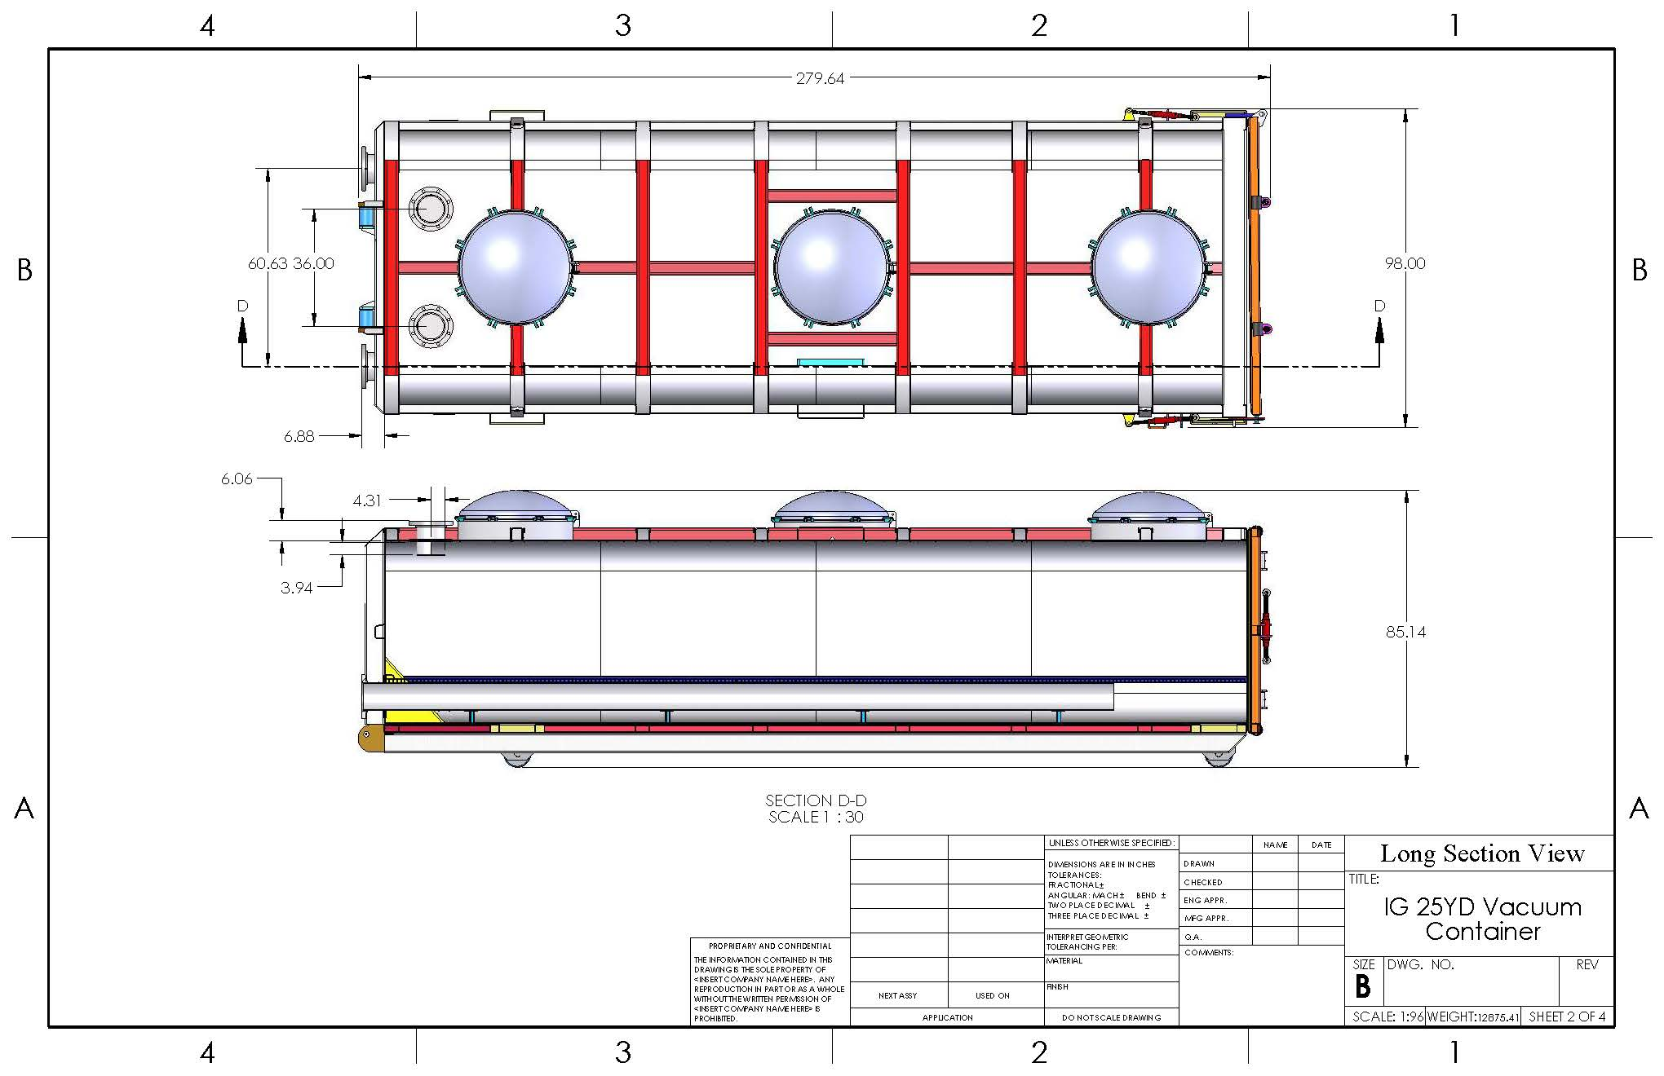

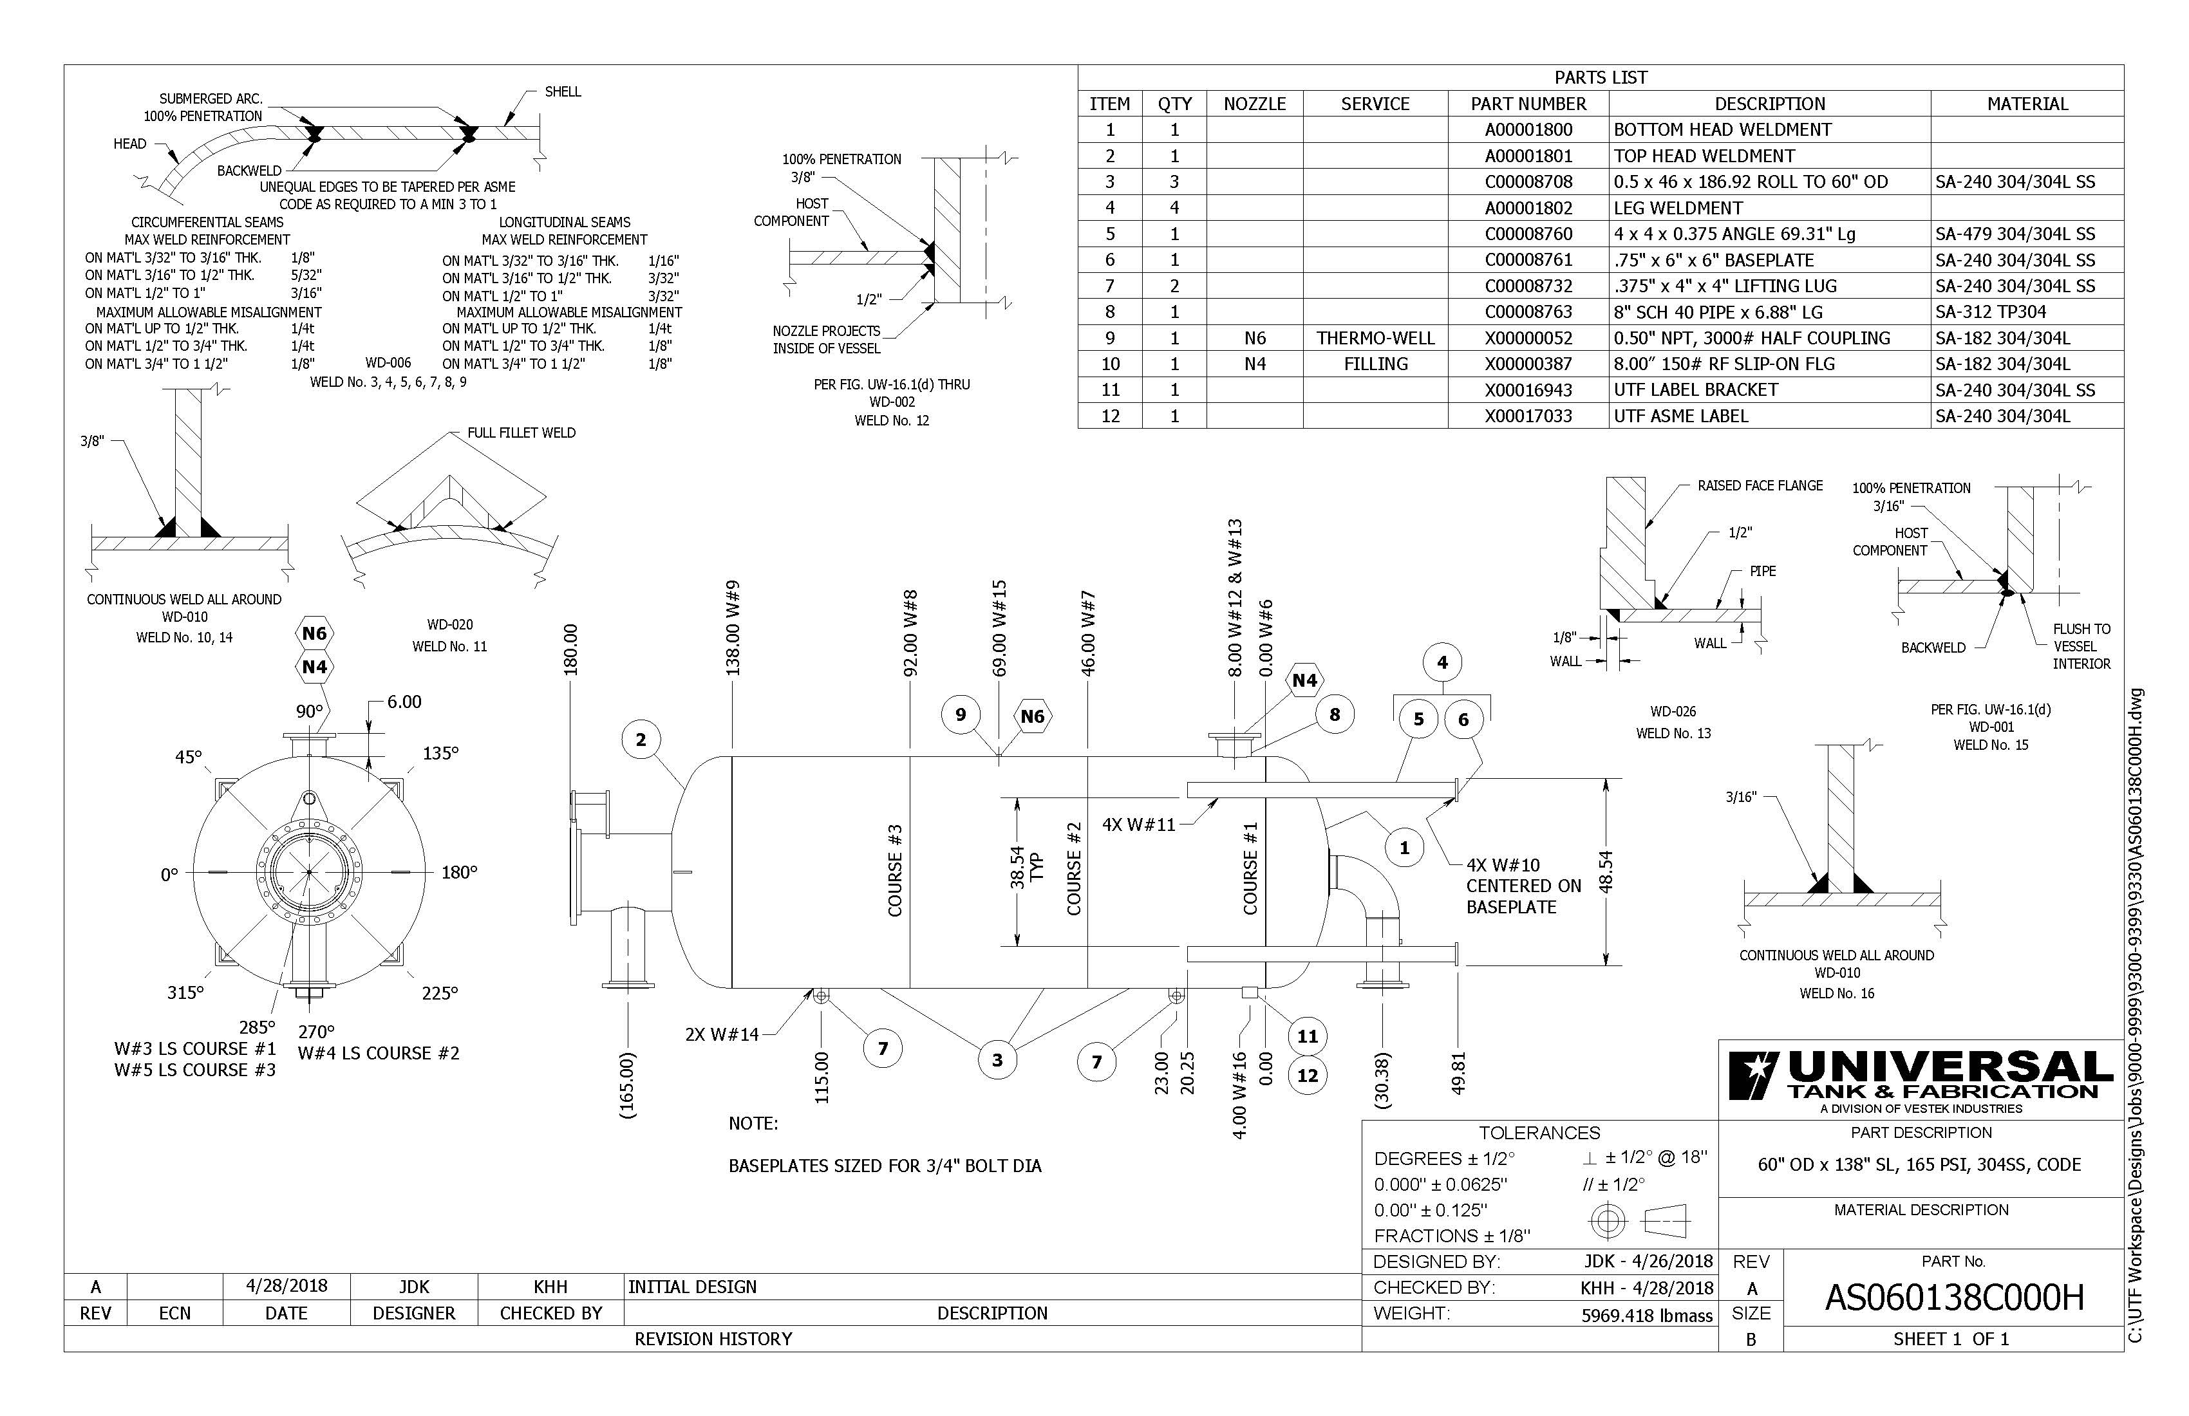

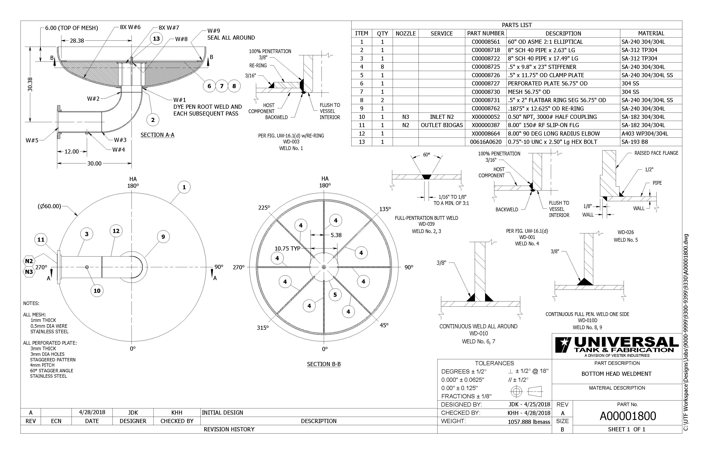

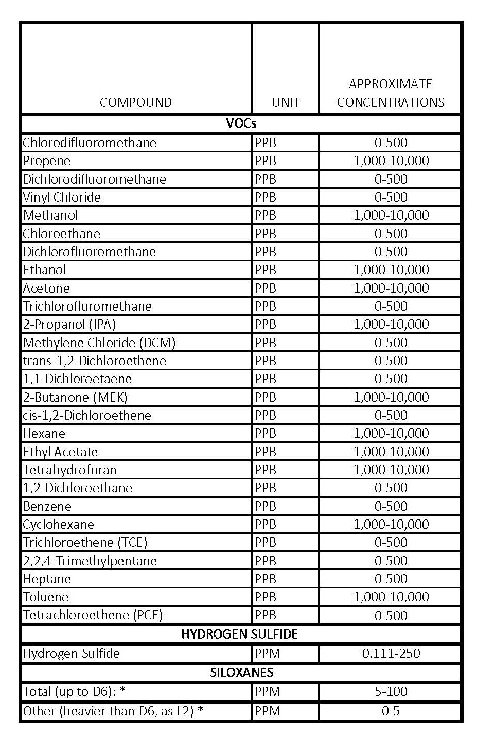
PRICE PROPOSAL

VENDOR NAME:
Pricing shall be inclusive of all labor, delivery costs and other expenses necessary to provide product in accordance with the specifications and terms and conditions of this bid document and your proposal. The estimated annual quantity is not a guaranteed quantity. Media will be ordered on an as needed basis.

Bidder does not have to provide pricing for each application if unable to offer a product that meets specifications. County reserves the right to select a different Bidder for each application based on product specifications, cost, and product availability.

If Bidder has multiple products available for an application, Bidder may indicate so and attach additional pricing sheets.

Pricing shall be fixed for a duration of 12 months. After initial 9 months of contract year, successful Bidder(s) will be given option to extend contract and pricing for another 12 month term.

Initial Contract Term (12 months)

# | APPLICATION 1 | Est. Annual Qty. | Pricing | UOM
1 | Media: ________________________ |  | $ | / LB.
2 | Estimated Loading Rate
3 | Estimated # of Change Outs Per Year
4 | Future Price Increases | Term 2____% Term 3____% Term 4____% Term 5____%

# | APPLICATION 2 | Est. Annual Qty. | Pricing | UOM
5 | Media: ________________________ |  | $ | / LB.
6 | Estimated Loading Rate
7 | Estimated # of Change Outs Per Year
8 | Future Price Increases | Term 2____% Term 3____% Term 4____% Term 5____%

# | APPLICATION 3 | Est. Annual Qty. | Pricing | UOM
9 | Media: ________________________ |  | $ | / LB.
10 | Estimated Loading Rate
11 | Estimated # of Change Outs Per Year
12 | Future Price Increases | Term 2____% Term 3____% Term 4____% Term 5____%

Comments

Additional Information Checklist – utilize the checklist below to ensure you have attached the additional information that is required for each proposed media to satisfy Specs 30-35.

Additional Information to Attach | Attached
Safety Data Sheet for the proposed material(s), showing the CAS number of the material. | □
Grain size analysis, and physical and chemical properties and photos of the raw and spent material(s). Evidence and/or testimony that disposal of spent product does not significantly contribute to formation of H2S when reintroduced to landfill waste mass. | □
Project reference list with operating conditions (inlet gas quality, operating pressures and temperatures, vessel types, H2S and VOC loads, and outlet quality) and anticipated removal capacities/loading rates for each application. Evidence or data that indicates the removal efficiency of the VOC media. | □
Quantities of current domestic and international stockpiles, storage locations, and any limitations on deliverable quantities. | □
Source of raw material, manufacturing location, a description of the process and capacity of the manufacturing facility. The County reserves the right to inspect the manufacturing and/or storage locations. | □
Contact information and resumes of customer sales and technical representative. Resumes must demonstrate experience with similar landfill gas projects and applications. | □

STANDARD TERMS AND CONDITIONS
Request for Bids/Proposals/Contracts
Rev. 11/2019

1.0 APPLICABILITY: The terms and conditions set forth in this document apply to Requests for Proposals (RFP), Bids and all other transactions whereby the County of Dane acquires goods or services, or both.

1.1 ENTIRE AGREEMENT: These Standard Terms and Conditions shall apply to any contract, including any purchase order, awarded as a result of this request. Special requirements of a resulting contract may also apply. Said written contract with referenced parts and attachments shall constitute the entire agreement, and no other terms and conditions in any document, acceptance, or acknowledgment shall be effective or binding unless expressly agreed to in writing by the County. Unless otherwise stated in the agreement, these standard terms conditions supersede any other terms and/or conditions applicable to this agreement.

1.2 DEFINITIONS: As used herein, “vendor” includes a provider of goods or services, or both, who is responding to an RFP or a bid, and “bid” includes a response to either an RFP or a bid.

2.0 SPECIFICATIONS: The specifications herein are the minimum acceptable. When specific manufacturer and model numbers are used, they are to establish a design, type of construction, quality, functional capability or performance level, or any combination thereof, desired. When alternates are proposed, they must be identified by manufacturer, stock number, and such other information necessary to establish equivalency. Dane County shall be the sole judge of equivalency. Vendors are cautioned to avoid proposing alternates to the specifications that may result in rejection of their bid.

3.0 DEVIATIONS AND EXCEPTIONS: Deviations and exceptions from terms, conditions, or specifications shall be described fully in writing, signed, and attached to the bid. In the absence of such statement, the bid shall be accepted as in strict compliance with all terms, conditions, and specifications and vendor shall be held liable for injury resulting from any deviation.

4.0 QUALITY: Unless otherwise indicated in the request, all material shall be first quality. No pre-owned, obsolete, discontinued or defective materials may be used.

5.0 QUANTITIES: The quantities shown herein are based on estimated needs. The County reserves the right to increase or decrease quantities to meet actual needs.

6.0 DELIVERY: Deliveries shall be FOB destination freight prepaid and included unless otherwise specified. County will reject shipments sent C.O.D. or freight collect.

7.0 PRICING: Unit prices shown on the bid shall be the price per unit of sale as stated on the request or contract. For any given item, the quantity multiplied by the unit price shall establish the extended price, the unit price shall govern in the bid evaluation and contract administration.
7.1 Prices established in continuing agreements and term contracts may be lowered due to market conditions, but prices shall not be subject to increase for the term specified in the award. Vendor shall submit proposed increases to the Purchasing Division thirty (30) calendar days before the proposed effective date of the price increase. Proposed increases shall be limited to fully documented cost increases to the vendor that are demonstrated to be industry wide. Price increases may not be granted unless they are expressed in bid documents and contracts or agreements.

7.2 Submission of a bid constitutes bidder’s certification that no financial or personal relationship exists between the bidder and any county official or employee except as specially set forth in writing attached to and made a part of the bid. The successful bidder shall disclose any such relationship which develops during the term of the contract.

8.0 ACCEPTANCE-REJECTION: Dane County reserves the right to accept or reject any or all bids, to waive any technicality in any bid submitted and to accept any part of a bid as deemed to be in the best interests of the County. Submission of a proposal or a bid constitutes the making of an offer to contract and gives the County an option valid for 60 days after the date of submission to the County.

8.1 Bids MUST be received in the electronic mailbox of the Dane County Purchasing Division on or before the date and time that the bid is specified as being due.

9.0 METHOD OF AWARD: Award shall be made to the lowest responsible responsive bidder conforming to specifications, terms, and conditions, or to the most advantageous bid submitted to the County on a quality versus price basis.

10.0 ORDERING/ACCEPTANCE: Written notice of award to a vendor in the form of a purchase order or other document, mailed or delivered to the address shown on the bid will be considered sufficient notice of acceptance of bid. A formal contract containing all provisions of the contract signed by both parties shall be used when required by the Dane County Purchasing Division.

11.0 PAYMENT TERMS AND INVOICING: Unless otherwise agreed, Dane County will pay properly submitted vendor invoices within thirty (30) days of receipt of goods and services. Payment will not be made until goods or services are delivered, installed (if required), and accepted as specified. Invoices presented for payment must be submitted in accordance with instructions contained on the purchase order.

11.1 NO WAIVER OF DEFAULT: In no event shall the making of any payment or acceptance of any service or product required by this Agreement constitute or be construed as a waiver by County of any breach of the covenants of the Agreement or a waiver of any default of the successful vendor, and the making of any such payment or acceptance of any such service or product by County while any such default or breach shall exist shall in no way impair or prejudice the right of County with respect to recovery of damages or other remedy as a result of such breach or default.

12.0 TAXES: The County and its departments are exempt from payment of all federal tax and Wisconsin state and local taxes on its purchases except Wisconsin excise taxes as described below. The State of Wisconsin Department of Revenue has issued tax exempt number ES41279 to Dane County.

12.1 The County is required to pay the Wisconsin excise or occupation tax on its purchase of beer, liquor, wine, cigarettes, tobacco products, motor vehicle fuel and general aviation fuel. The County is exempt from Wisconsin sales or use tax on these purchases. The County may be subject to other states’ taxes on its purchases in that state depending on the laws of that state. Vendors performing construction activities are required to pay state use tax on the cost of materials.

13.0 GUARANTEED DELIVERY: Failure of the vendor to adhere to delivery schedules as specified or to promptly replace rejected materials shall render the vendor liable for all costs in excess of the contract price when alternate procurement is necessary. Excess costs shall include administrative costs.

14.0 APPLICABLE LAW AND VENUE: This contract shall be governed under the laws of the State of Wisconsin, and venue for any legal action between the parties shall be in Dane County Circuit Court. The vendor shall at all times comply with and observe all federal and state laws, local laws, ordinances, and regulations which are in effect during the period of this contract and which in any manner affect the work or its conduct.

15.0 ASSIGNMENT: No right or duty in whole or in part of the vendor under this contract may be assigned or delegated without the prior written consent of Dane County.

16.0 NONDISCRIMINATION/AFFIRMATIVE ACTION: During the term of this Agreement the vendor agrees, in accordance with sec. 111.321, Wis. Stats., and Chapter 19 of the Dane County Code of Ordinances, not to discriminate against any person, whether an applicant or recipient of services, an employee or applicant for employment, on the basis of age, race, ethnicity, religion, color, gender, disability, marital status, sexual orientation, national origin, cultural differences, ancestry, physical appearance, arrest record or conviction record, military participation or membership in the national guard, state defense force or any other reserve component of the military forces of the United States, or political beliefs. The vendor shall provide a harassment-free work environment. These provisions shall include, but not be limited to, the following: employment, upgrading, demotion, transfer, recruitment, advertising, layoff, termination, training, including apprenticeships, rates of pay or other forms of compensation.

16.1 Vendors who have twenty (20) or more employees and a contract of twenty thousand dollars ($20,000) or more must submit a written affirmative action plan to the County’s Contract Compliance Officer within fifteen (15) working days of the effective date of the contract. The County may elect to accept a copy of the current affirmative action plan filed with and approved by a federal, state or local government unit.

16.2 The vendor agrees to post in conspicuous places, available for employees and applicants for employment, notices setting forth the provisions of this Agreement as they relate to affirmative action and nondiscrimination.

16.3 Failure to comply with these Terms and Conditions may result in the vendor being debarred, termination of the contract and/or withholding of payment.

16.4 The vendor agrees to furnish all information and reports required by Dane County’s Contract Compliance Officer as the same relate to affirmative action and nondiscrimination, which may include any books, records, or accounts deemed appropriate to determine compliance with Chapter 19, D.C. Ords. and the provisions of this Agreement.

16.5 AMERICANS WITH DISABILITIES ACT: The vendor agrees to the requirements of the ADA, providing for physical and programmatic access to service delivery and treatment in all programs and activities.

17.0 PATENT, COPYRIGHT AND TRADEMARK INFRINGEMENT: The vendor guarantees goods sold to the County were manufactured or produced in accordance with applicable federal labor laws, and that the sale or use of the articles described herein do not infringe any patent, copyright or trademark. The vendor covenants that it will, at its own expense, defend every suit which shall be brought against the County (provided that such vendor is promptly notified of such suit, and all papers therein are delivered to it) for any alleged infringement of any patent, copyright or trademark by reason of the sale or use of such articles, and agrees that it will pay all costs, damages, and profits recoverable in any such suit.

18.0 SAFETY REQUIREMENTS: All materials, equipment, and supplies provided to the County must fully comply with all safety requirements as set forth by the Wisconsin Department of Commerce and all applicable OSHA Standards.

18.1 MATERIAL SAFETY DATA SHEET: If any item(s) on an order(s) resulting from this award(s) is a hazardous chemical, as defined under 29 CFR 1910.1200, provide one (1) copy of the Material Safety Data Sheet for each item with the shipped container(s) and one (1) copy with the invoice(s).

19.0 WARRANTY: Unless specifically expressed otherwise in writing, goods and equipment purchased as a result of this request shall be warranted against defects by the vendor for one (1) year from date of receipt. An equipment manufacturer’s standard warranty shall apply as a minimum and must be honored by the vendor.

20.0 INDEMNIFICATION & INSURANCE.

20.1. Vendor shall indemnify, hold harmless and defend County, its boards, commissions, agencies, officers, employees and representatives against any and all liability, loss (including, but not limited to, property damage, bodily injury and loss of life), damages, costs or expenses which County, its officers, employees, agencies, boards, commissions and representatives may sustain, incur or be required to pay by reason of vendor furnishing the services or goods required to be provided under this Agreement, provided, however, that the provisions of this paragraph shall not apply to liabilities, losses, charges, costs, or expenses caused by or resulting from the acts or omissions of County, its agencies, boards, commissions, officers, employees or representatives. The obligations of vendor under this paragraph shall survive the expiration or termination of this Agreement.

20.2. In order to protect itself and County its officers, boards, commissions, agencies, agents, volunteers, employees and representatives under the indemnity provisions of the subparagraph above, vendor shall, at vendor’s own expense, obtain and at all times during the term of this Agreement keep in full force and effect the insurance coverages, limits, and endorsements listed below. When obtaining required insurance under this Agreement and otherwise, vendor agrees to preserve County’s subrogation rights in all such matters that may arise that are covered by vendor’s insurance. Neither these requirements nor the County’s review or acceptance of vendor’s certificates of insurance is intended to limit or qualify the liabilities or obligations assumed by the vendor under this Agreement. The County expressly reserves the right to require higher or lower insurance limits where County deems necessary.

20.2.1. Commercial General Liability.
Vendor agrees to maintain Commercial General Liability insurance at a limit of not less than $1,000,000 per occurrence. Coverage shall include, but not be limited to, Bodily Injury and Property Damage to Third Parties, Contractual Liability, Personal Injury and Advertising Injury Liability, Premises-Operations, Independent vendors and Subcontractors, and Fire Legal Liability. The policy shall not exclude Explosion, Collapse, and Underground Property Damage Liability Coverage. The policy shall list DANE COUNTY as an Additional Insured.

20.2.2. Commercial/Business Automobile Liability.
Vendor agrees to maintain Commercial/Business Automobile Liability insurance at a limit of not less than $1,000,000 Each Occurrence. Vendor further agrees coverage shall include liability for Owned, Non-Owned & Hired automobiles. In the event vendor does not own automobiles, vendor agrees to maintain coverage for Hired & Non-Owned Auto Liability, which may be satisfied by way of endorsement to the Commercial General Liability policy or separate Business Auto Liability policy.

20.2.3. Environmental Impairment (Pollution) Liability
Vendor agrees to maintain Environmental Impairment (Pollution) Liability insurance at a limit of not less than $1,000,000 per occurrence for bodily injury, property damage, and environmental cleanup costs caused by pollution conditions, both sudden and non-sudden. This requirement can be satisfied by either a separate environmental liability policy or through a modification to the Commercial General Liability policy. Evidence of either must be provided.

20.2.4. Workers’ Compensation.
Vendor agrees to maintain Workers Compensation insurance at Wisconsin statutory limits.

20.2.5. Umbrella or Excess Liability.
Vendor may satisfy the minimum liability limits required above for Commercial General Liability and Business Auto Liability under an Umbrella or Excess Liability policy. There is no minimum Per Occurrence limit of liability under the Umbrella or Excess Liability; however, the Annual Aggregate limit shall not be less than the highest “Each Occurrence” limit for the Commercial General Liability and Business Auto Liability. vendor agrees to list DANE COUNTY as an “Additional Insured” on its Umbrella or Excess Liability policy.

20.3. Upon execution of this Agreement, vendor shall furnish County with a Certificate of Insurance listing County as an additional insured and, upon request, certified copies of the required insurance policies. If vendor's insurance is underwritten on a claims-made basis, the retroactive date shall be prior to or coincide with the date of this Agreement, the Certificate of Insurance shall state that professional malpractice or errors and omissions coverage, if the services being provided are professional services coverage is claims-made and indicate the retroactive date, vendor shall maintain coverage for the duration of this Agreement and for six (6) years following the completion of this Agreement. Vendor shall furnish County, annually on the policy renewal date, a Certificate of Insurance as evidence of coverage. It is further agreed that vendor shall furnish the County with a 30-day notice of aggregate erosion, in advance of the Retroactive Date, cancellation, or renewal. It is also agreed that on claims-made policies, either vendor or County may invoke the tail option on behalf of the other party and that the extended reporting period premium shall be paid by vendor. In the event any action, suit or other proceeding is brought against County upon any matter herein indemnified against, County shall give reasonable notice thereof to vendor and shall cooperate with vendor's attorneys in the defense of the action, suit or other proceeding. Vendor shall furnish evidence of adequate Worker's Compensation Insurance. In case of any sublet of work under this Agreement, vendor shall furnish evidence that each and every subcontractor has in force and effect insurance policies providing coverage identical to that required of vendor. In case of any sublet of work under this Agreement, vendor shall furnish evidence that each and every subcontractor has in force and effect insurance policies providing coverage identical to that required of vendor.

20.4. The parties do hereby expressly agree that County, acting at its sole option and through its Risk Manager, may waive any and all requirements contained in this Agreement, such waiver to be in writing only. Such waiver may include or be limited to a reduction in the amount of coverage required above. The extent of waiver shall be determined solely by County's Risk Manager taking into account the nature of the work and other factors relevant to County's exposure, if any, under this Agreement.

21.0 CANCELLATION: County reserves the right to terminate any Agreement due to non-appropriation of funds or failure of performance by the vendor. This paragraph shall not relieve County of its responsibility to pay for services or goods provided or furnished to County prior to the effective date of termination.

22.0 PUBLIC RECORDS ACCESS: It is the intention of the County to maintain an open and public process in the solicitation, submission, review, and approval of procurement activities. Bid openings are public unless otherwise specified. Records are not available for public inspection prior to issuance of the notice of intent to award or the award of the contract. Bid results may be obtained by visiting the Dane County Purchasing Office Monday – Friday, between 8:00 a.m. and 4:00 p.m. Prior appointment is advisable.

22.1 PROPRIETARY INFORMATION: If the vendor asserts any of its books and records of its business practices and other matters collectively constitute a trade secret as that term is defined in s. 134.90(1)(c), Wis. Stats., County will not release such records to the public without first notifying the vendor of the request for the records and affording the vendor an opportunity to challenge in a court of competent jurisdiction the requester’s right to access such records. The entire burden of maintaining and defending the trade secret designation shall be upon the vendor. The vendor acknowledges and agrees that if the vendor shall fail, in a timely manner, to initiate legal action to defend the trade secret designation or be unsuccessful in its defense of that designation, County shall be obligated to and will release the records.

22.2 Any material submitted by the vendor in response to this request that the vendor considers confidential and proprietary information and which vendor believes qualifies as a trade secret, as provided in section 19.36(5), Wis. Stats., must be identified on a designation of Confidential and Proprietary Information form. Pricing will not be held confidential after award of contract.

22.3 Data contained in a bid, all documentation provided therein, and innovations developed as a result of the contracted commodities or services cannot be copyrighted or patented. All data, documentation, and innovations shall be the property of the County.

23.0 RECYCLED MATERIALS: Dane County is required to purchase products incorporating recycled materials whenever technically and economically feasible. Vendors are encouraged to bid products with recycled content which meet specifications.

24.0 PROMOTIONAL ADVERTISING: Reference to or use of Dane County, any of its departments or sub-units, or any county official or employee for commercial promotion is prohibited.

25.0 ANTITRUST ASSIGNMENT: The vendor and the County of Dane recognize that in actual economic practice, overcharges resulting from antitrust violation are in fact usually borne by the Purchaser. Therefore, the successful vendor hereby assigns to the County of Dane any and all claims for such overcharges as to goods, materials or services purchased in connection with this contract.

26.0 RECORDKEEPING AND RECORD RETENTION-COST REIMBURSEMENT CONTRACTS: Where payment to the vendor is based on the vendor’s costs, vendor shall establish and maintain adequate records of all expenditures incurred under the contract. All records must be kept in accordance with generally accepted accounting procedures. The County contracting agency shall have the right to audit, review, examine, copy, and transcribe any pertinent records or documents relating to any contract resulting from this bid/proposal held by the vendor. The vendor will retain all documents applicable to the contract for a period of not less than three (3) years after final payment is made.

27.03 COMPLIANCE WITH FAIR LABOR STANDARDS. During the term of this Agreement, vendor shall report to the Controller, within ten (10) days, any allegations to, or findings by the National Labor Relations Board (NLRB) or Wisconsin Employment Relations commission (WERC) that vendor has violated a statute or regulation regarding labor standards or relations within the seven years prior to entering this Agreement. If an investigation by the Controller results in a final determination that the matter adversely affects vendor’s responsibilities under this Agreement, and which recommends termination, suspension or cancellation of this agreement, the County may take such action.

27.04 VENDOR may appeal any adverse finding by the Controller as set forth in sec. 25.08(20)(c) through (e).

27.05 VENDOR shall post the following statement in a prominent place visible to employees: “As a condition of receiving and maintaining a contract with Dane County, this employer shall comply with federal, state and all other applicable laws prohibiting retaliation for union organizing.

